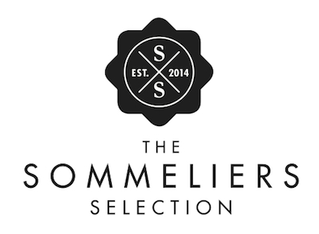

2019 ENTRY INFORMATION PACK
ENTRIES FOR THE 2019 SOMMELIERS SELECTION COMPETITION ARE NOW OPEN!
1. COMPLETE YOUR ENTRY
- All Entries are done online via the link below:
https://forms.gle/t94iTU4sD6BZHtuaA
2. WINES
- All wines must be market ready
- All wines must be final bottled product
- No tank or barrel samples will be accepted
- A minimum of 300 bottles x 750ml must be available on site on day of results
- Minimum quantity not applicable to Cellar Selection
- We welcome vintage diversity in all categories
- We reserve the right to move wine into a more suitable category if deemed appropriate.
3. ENTRY FEE:
- R995-00 per wine entered (ex VAT) (price has stayed the same as 2018)
- An invoice will be sent to participants on receipt of entry form, payment due within 7 days
- Invoice will be sent by Elaine Maritz – elaine@finleys.co.za
- A proof of payment must be mailed directly to Elaine - elaine@finleys.co.za
- Payment Details:
  - DnA Events
Investec Private Bank
Acc no: 10011895466
Branch Code: 580 105
4. SAMPLES
- 4 x 750 ml bottles of each wine
- 3 x 375 ml of Stickies and Fortified
- 6 x bottles of Beer
- 2 x bottles of Spirits
5. DELIVERIES
- Wines to be delivered Monday 2 September 2019: 10h00 – 15h00 ONLY
  - Wines to be delivered to:
Joostenberg Deli & Bistro
R304, Stellenbosch, 7600
- Please deliver to the events venue behind the Bistro.
- Map: http://www.joostenberg.com/contact.html
- Each case must be clearly marked for The Sommeliers Selection
- All wines must be packed and sealed into a box with the category clearly marked on the box.
6. LISTED WINES
- R 3 500 & 12 bottles payable per Listed wine
- This includes:
  - 2000 Necktags and 2000 Stickers OR:
  - 4000 x Stickers only
  - (Extra Stickers and Necktags can be purchased at a cost of R375/1000)
7. AWARDS, THE PUBLIC & TRADE TASTINGS:
- Awards: Wednesday 9 October
  - Café Roca, Franschhoek, 14h00 – 16h00
- Public & Trade Tastings:
  - Media & Trade: 16h00 – 18h00
  - Public Event: 18h00 – 21h00
- Cape Town – Tsogo Sun, Sun Square – 11 October
- Johannesburg –Tsogo Sun - Hyde Park – Wednesday 16 October
- Durban – Tsogo Sun - The Beverly Hills – 25 October

8. EXPOSURE & WINNING PERKS:
- 3 or more social media campaigns specifically featuring your listed wines
- Wine List sent to our extensive restaurant and trade database.
- Wines to be shown at 3 Regional trade & public shows
- Wines to be recognised as SS wines on the Tsogo Sun wine list
- A Selection of Listed Wines to be listed at Roca Restaurant – Franschhoek
- A Selection of Listed Bubbles & Rosé and Whites to be listed at Café Marilyn- Franschhoek
- A Selection of Listed wines to be listed at Café Roca – Franschhoek
- 15% off all Stand fees for the following festivals:
  - The Chocolate Festival
  - Beer, Bubbly & Wine
  - The Johannesburg Cap Classique & Champagne Festival
  - The Durban Cap Classique & Champagne festival
  - Any other festivals owned by DNA Events.

9. DISQUALIFICATION RULE
- All wines received must adhere to the WSB certification
- Any wines not adhering to the terms & conditions will be automatically disqualified
- The Judge’s decision is final

10. JUDGING PROTOCOL
- The Sommelier Selection offers a new perspective on wine competitions and ratings.
- Wines are assessed exclusively by professionally trained sommeliers who evaluate entries as they would consider wines for designing a wine list.
- This provides the consumer with tangible and practical solutions to their wine quality expectations at various price points.
- Wines are judged blind, by 1 chairman, two panels consisting of 3 sommeliers and one associate each, not in context of grape variety, but rather wine style and price point.
- Winning wines are awarded listings on this exclusive ‘wine list’ and the title of Sommelier Selection Listed Wine.
- This process eliminates the confusing aesthetics of awarding medals and scores, providing the market with a finite selection of winning wines within a preferred style or category of wines.
- It further avoids the often “unfair” process where wines have to compete with vastly different priced counterparts that happen to be made from the same grape variety.
- Wines across all price points and styles are eligible for awards.
- The 7 senior tasters all have extensive experience in evaluating wines and crafting innovative wine programs.
- The Sommelier Selection partners with professional sommeliers for creative inputs and judging resources.

11. CATEGORIES:
- Economically Savvy (R80 or under Trade price)
a) Whites
b) Reds
c) Pinks
d) Fizz (MCC & Sparkling Wines)
- Whites
a) Fresh/Crunchy
b) Elegant/Classy
c) Voluptuous/Rich
d) Luscious/Aromatic
- Pinks
- Reds
a) Fresh/Crunchy
b) Elegant/Classy
c) Voluptuous/Rich
- Fizz
- Pale Fizz
- Rosé Fizz
- Vintage Fizz
- Stickies & Fortified Wines
- Cellar Selection - Aged wines, Flagship wines & higher price point wines
as well as wine that you believe will improve significantly with at least five years of age.
- Spirits
- Craft Beer
- The number of winners in each category will depend entirely on the calibre of entries.
- Wine selections are made as if deciding on wines for an exclusive, top wine list.
- Winning wines are awarded the title of ‘Sommelier Selection Listed Wines’, along with the category in which it achieved selection.
- If judges don’t find suitable quality in a particular category, then there will be no listings from that category for that year.
- Listed wines will be published and marketed in a typical restaurant wine list format, meant to be a promotional tool for The Sommelier Selection, but also for trade in general throughout the year.
- Fun and descriptive neck tags will be made available to producers.

12. TASTING PROTOCOL & CRITERIA:
- The Sommeliers Selection provides an alternative view on wine awards that focuses entirely on translating wine awards to the end consumer in a context that is familiar to all – restaurants.
- It achieves this while not compromising at all on objectivity (all wines tasted blind at all times) or professionalism.
- Wines have to be available to the local trade. All wines entered must be market ready and the final bottled product.
- Minimum stock requirement for entry: 300 bottles on premises on day of results (not including Cellar Selection or Craft).
- Four bottles of each wine to be made available for judging process. If a wine is perceived to have a bottle fault, another bottle will be assessed. Four similar bottle faults in a row for one wine will result in disqualification of that wine.
- White wines will be served at 13°C
- Red wines will be served at 18°C
- Bubblies and Stickies will be served at 7°C
- Wines judged in the ‘Cellar Selection’ category will be decanted a few hours before assessment to allow full expression and simulate the setting these wines would be appreciated in, in a fine dining environment.
- Judges will look to award food friendliness, versatility, fruit purity, character and value for money, the typical considerations when looking for wines to use in a progressive restaurant wine program.
13. JUDGING PROCESS
- Two panels, each consisting of 3 qualified sommeliers and one associate taster. Associate taster’s score does not contribute to the recorded average.
- Wines are tasted blind – Only Price point & Vintage & Size Format of wine is shown
- Wines scored out of 100
- Discussion after each flight allowing for calibration and capturing scores. Wines with best average scores and the judge’s agreement in each category are awarded places on Sommelier Selection list
- A maximum of 100 wines will be tasted per panel per day
- Professional glassware used throughout judging process
14.JUDGING PANEL
- Barry Scholfield – SASA Chairman
- Chantelle Gous – Singita Group
- Esmé Groenewald
- Joakim Hansi Blackadder (Chair)
- Joseph Dhafana – Le Colombe
- Pearl Oliver-Mbumba – The One & Only
- Tinashe Nyamudoka – The Test Kitchen
- Wayve Kolevsohn – Ellerman House
- Wikus Human – Marble & Saint (JHB)
Judges Bios:

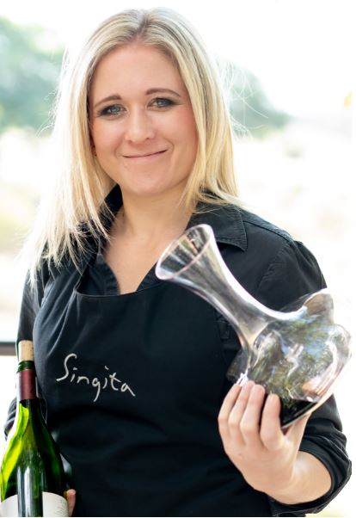
CHANTELLE GOUS:
After completing her studies in Stellenbosch, Chantelle Gous (32) left South Africa to work in Canada for 4x years. Her interest in wine was peaked after working in a contemporary family restaurant and helping out in an Italian wine store part-time. She completed her WSET3 in Canada before returning to South Africa where she immediately started working with Singita Conservation Company in the Sabi Sand Game Reserve adjacent to the Kruger National Park where she has progressed and twice promoted to be Senior Sommelier Operations. After working at the Sabi Sand Singita lodges for the past 4x years, she has recently ‘returned’ to the Cape Winelands where she is working with Francois Rautenbach as part of the Singita Premierwine Direct team.

Cape-Town born, Wayve graduated from the Cape town Hotel School and headed off to London where she started her career at Michelin starred restaurant, Chez Bruce. Upon her return and after completing a post-graduate degree in management, she spent the next few years working as the Restaurant Manager at the world famous restaurant, The Tasting Room at Le Quartier Francais and then as Head Sommelier of The Test Kitchen in Cape Town.
Wayve completed her wine studies through the WSET and London Wine & Spirit School, and in 2015 moved to Asia where she managed the wine department as Head Sommelier for LVMH-owned luxury resort Cheval Blanc Randheli in the Maldives. In 2018, Wayve completed a 5 week harvest internship at Fable Mountain Vineyards. Currently, she is a board member of The South African Sommelier Association and is the Head Sommelier of Ellerman House Luxury Hotel & Villas.

In 2009 Pearl won Best Wine Steward of the Year in the Diners Club Wine list award, kickstarting her career she spent 3 years at the Belthazar Restaurant and Wine Bar, before she took on the position of Sommelier at Myoga restaurant with Michelin star Chef Mike Basset. She then joined the team at the Planet restaurant at the Mount Nelson Hotel. Pearl then continued on the as a Sommelier & Beverage manager at Cape Town’s five-star Taj Hotel, after which she managed The Vista bar and lounge at One & Only Cape Town. Pearl currently serves as Resort Sommelier at the One & Only hotel.
Pearl has a Post Grad in Wine Business management from the University of Cape Town’s Graduate School of Business, She has judged on a number of wine panels is currently an elect Honorary Executive Board member of the South African Sommelier Association while she was recently voted as the National Chairperson to the board of the Black Cellar Club in established in 2016.

